Creating metrics

1. To start with, click Enter Data from Home menu.

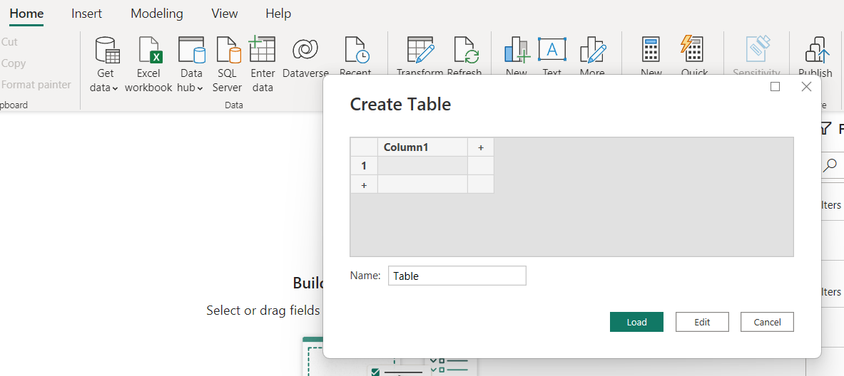

1. Rename it as “Measure Table” and load.
2. Right click to the Measure Table and click “New Measure”.

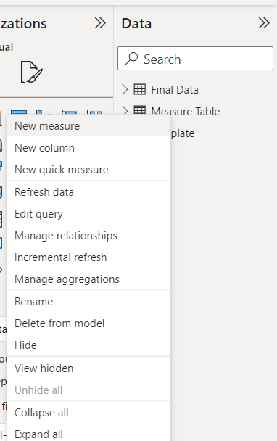

1. First of all we need to know “Total working days”.

Apart from Weekly Off – WO, Holiday Off – HO, everything is total working days.

1. 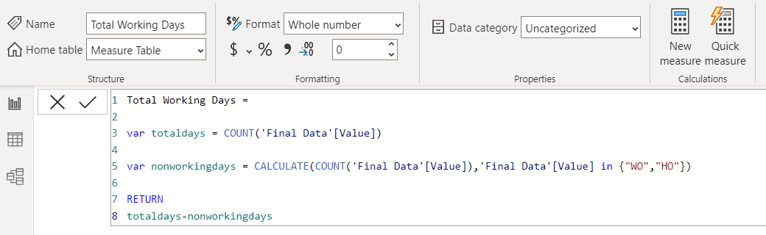Drag the measure to dashboard field and change the visual to “Card”.

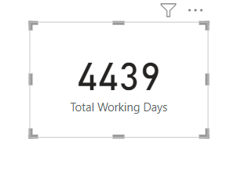

1. From total working days of all the employees we need to understand percentage of people who are present. For that we need to know the number of days people are present.

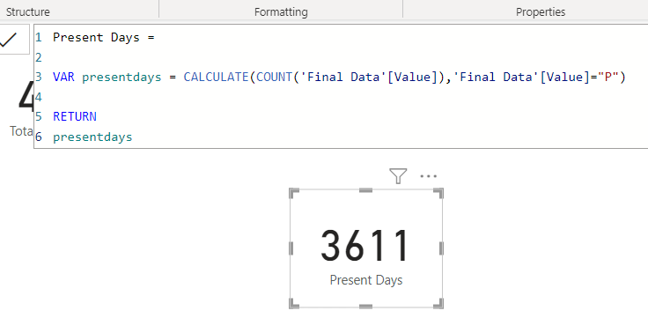

1. It only takes present days. But we need to know half work from home and half work office counts also. For that we will change in table level.
2. Go to “Data view” and click “final data” from right top corner. And create a column, if it is WFH then it is 1. If it is half WFH then it is 0.5

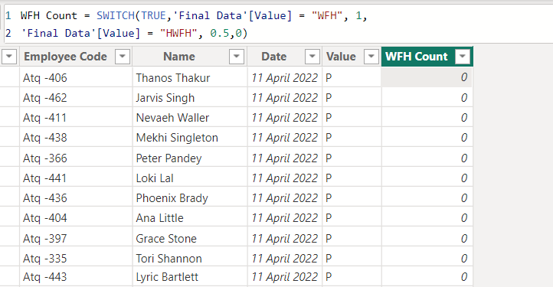

1. Then go to report view and create a measure in measure table about the sum of wfh count.

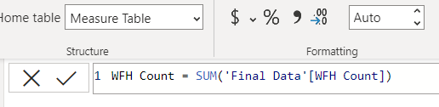

1. Now we need to adjust the present days formula with WFH count.

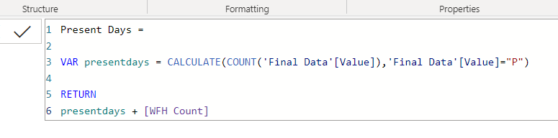

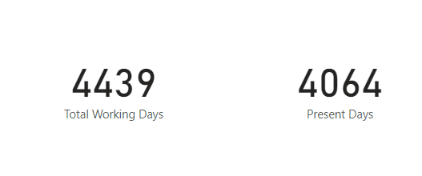

1. Now we need to get presence percentage.

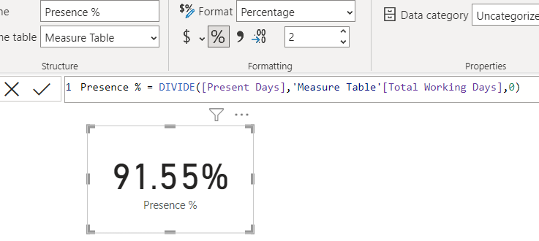

1. To visualize the things better, we will add slicer and will add the dates.

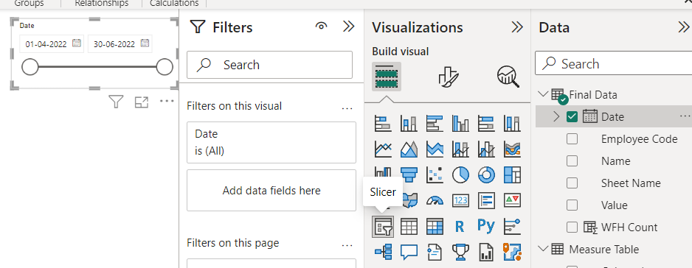

1. We need month wise data to show in metrics. For that we will go to Data view and add a column as month.

